

Informatica Export Run Guide

Version 1.0

# 

Table of Contents

1. Introduction 3

1.1 Overview 3

2. Configuring the query in informatica PowerCenter 3

2.1 Query config in PowerCenter 3

3. Configuring the batch file 4

3.1 Configuring the batch file 4

3.2 Execution of the batch file 7

1. Introduction
   1. Overview

The Informatica export batch file will export all the mapping from PowerCenter automatically in local system.

The operation consists of two parts.

1. Create the mapping query rules to export the mappings in PowerCenter.
2. Run the batch file to export all the mappings automatically based on query rules.

# 

1. Configuring the query in informatica PowerCenter
   1. Query Config in PowerCenter

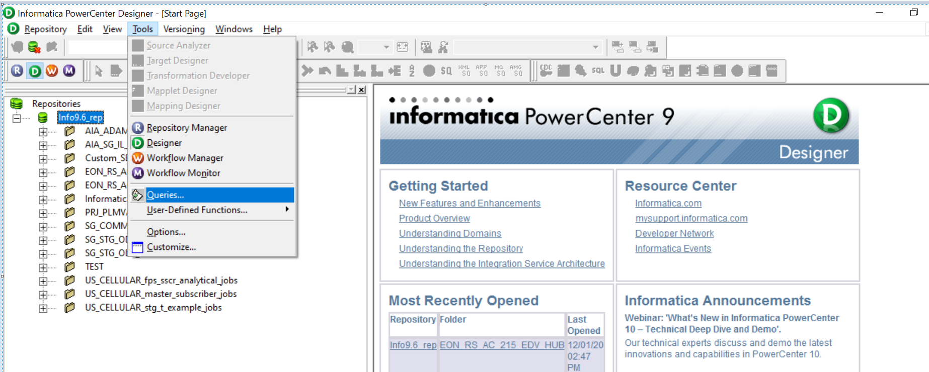

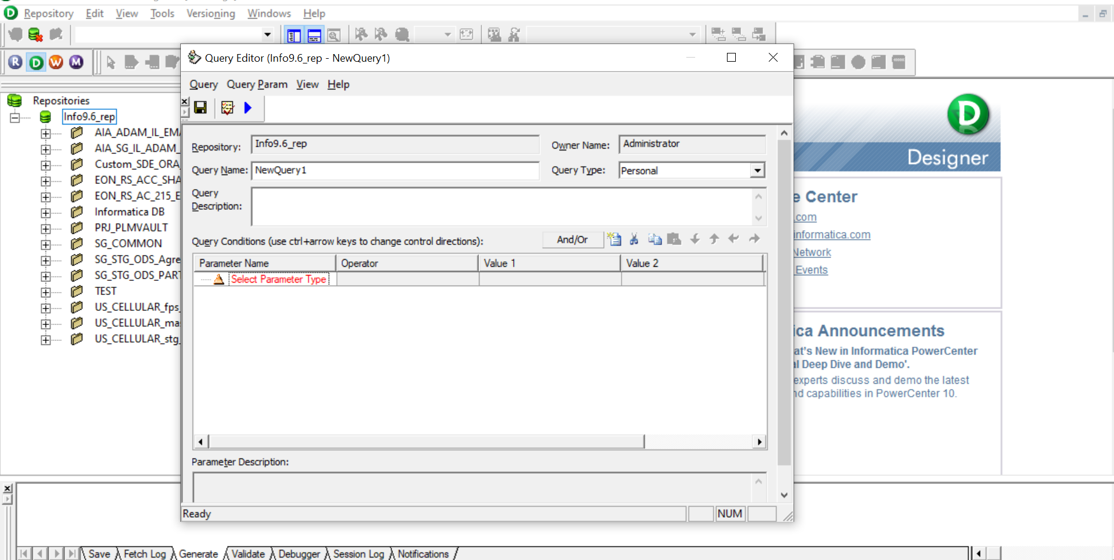

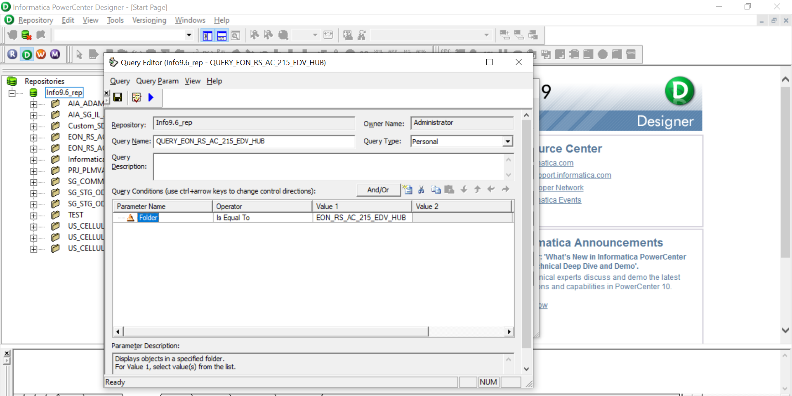

1. Config the Batch File
   1. Configuring the batch file

* Create a local folder and place the Windows Batch Script to export the mapping in XML format.
* **Informatica.bat** is the Batch script to export the mapping and **INFA_EXPORT** folder will act as a placeholder for the exported files.

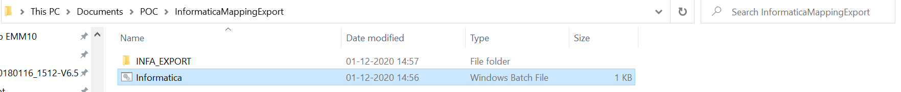

* 1. Execution of the batch file

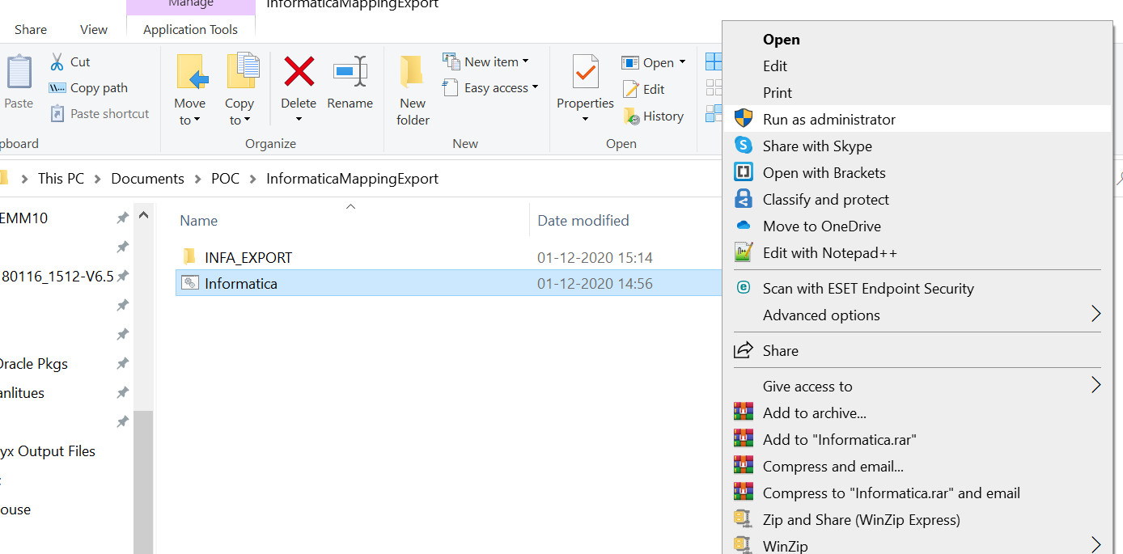

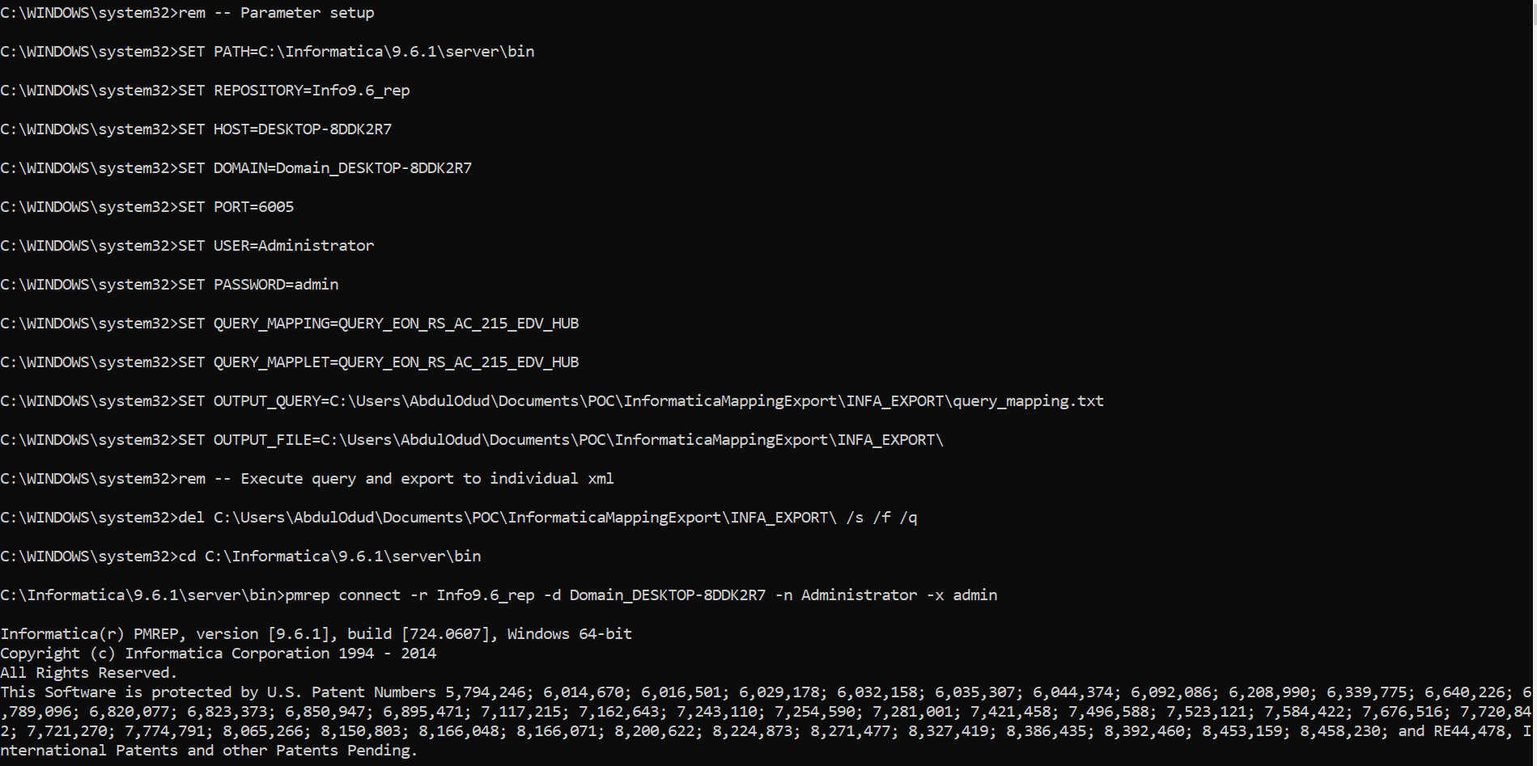

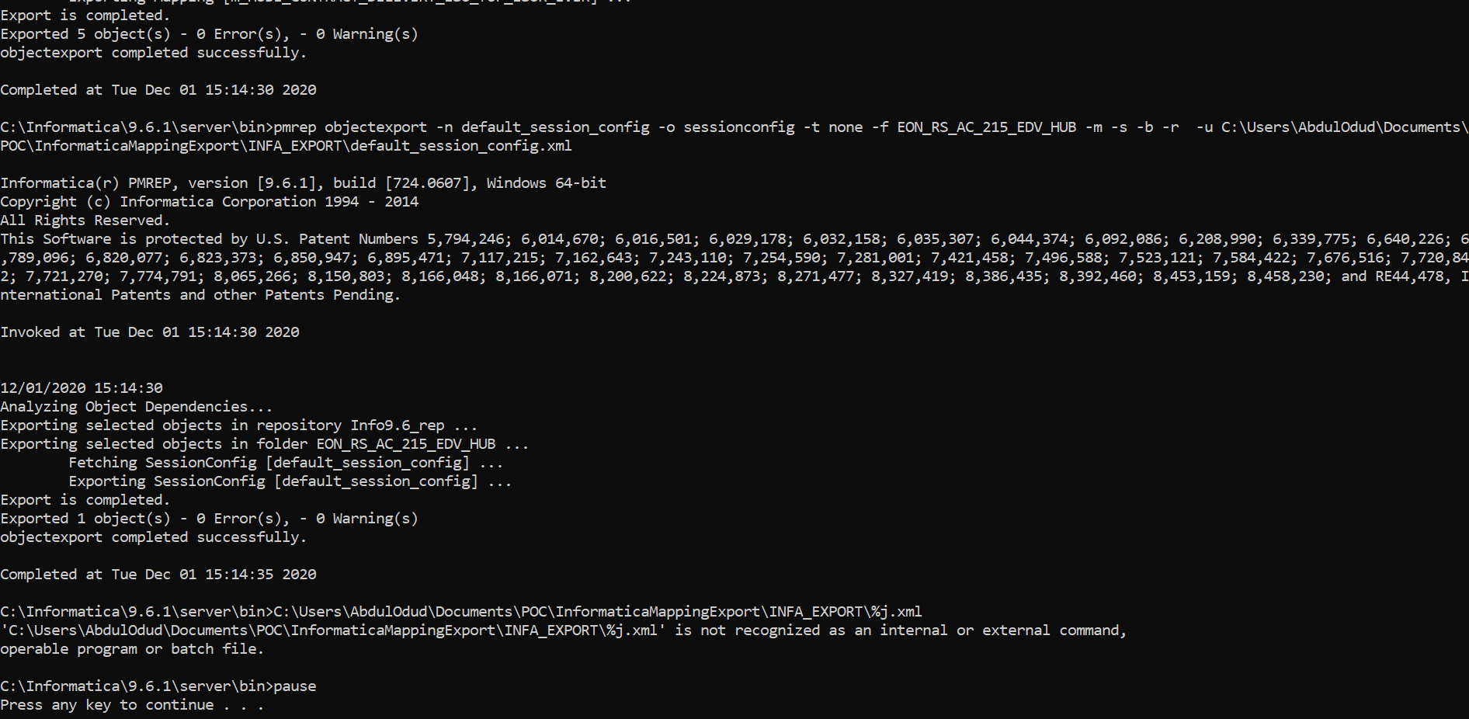

**Exported Items in Local:**

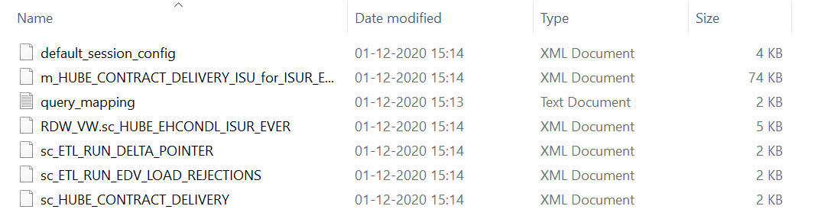

**Script:**

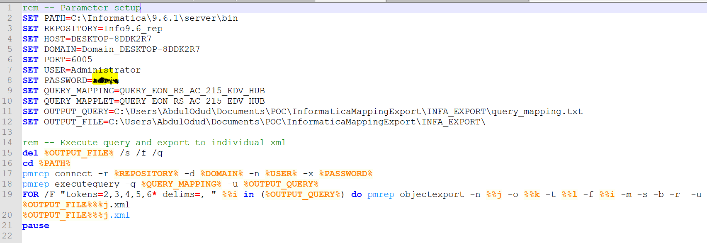

**Option / Config Details in BAT file:**

**PATH:** Provide the path where informatica server is installed.

**REPOSITORY:** Informatica repo folder name.

**HOST/DOMAIN/PORT:** Provide the HOST and Domain and PORT details associated with Informatica.

**USER/PASSWORD**: Need to put login details in Informatica tool.

**QUERY_MAPPING:** Mention the Query mapping name.

**OUTPUT_QUERY:** Path where query_mapping.txt will export.

**OUTPUT_FILE:** Path where all the mapping will export.